# Selecting Text to append to Rubric Element Evidence/Notes

Previous to this update, the Notes Editor allowed the user to create an excerpt aligned to a specific framework criteria by selecting the text and create and clicking the appropriate editor toolbar button that corresponded to the framework criteria (for example, C1, C2, etc.) As a second step, the user could switch to the Rubric View, view the excerpt, and then could select a sub-portion of that excerpt and further align it to a specific rubric element. That process would add the selected text to the Evidence/Notes for the selected rubric element.

In this update the Notes Editor toolbar has been expanded to include buttons for each of the rubric elements so that the user can perform the process of aligning text to specific rubric elements directly from the editor. For example, the user can select some text, click the “2b” toolbar button next to the “C1” button, and then the selected text will be appended to the Evidence/Notes for the C1/2b rubric element.

**Testing with different Evaluation Frameworks**

Different districts use different evaluation frameworks. We need to verify that the correct options are configured for the Notes Editor depending on which evaluation framework is active. The following table lists each of the possible evaluation frameworks.

* **Framework:** The name of the framework
* **Login:** the account to use to test
* **State:** whether the framework supports a state view (this is always the case)
* **Instructional:** whether the framework supports an instructional view.
* **Rubric View Dropdown Visible:** whether the dropdown to select whether to display the state vs the instructional toolbar buttons is visible. It will only be visible if the framework supports both. Otherwise it is hidden.

|  |  |  |  |  |
| --- | --- | --- | --- | --- |
| **Framework** | **Login** | **State** | **Instructional** | **Rubric View Dropdown Visible** |
| Danielson Teacher | Aberdeen SD School 1 PR | Yes | Yes | Yes |
| Marzano Teacher | Brewster SD School 1 PR | Yes | Yes | Yes |
| CEL Teacher | Adna SD School 1 PR | Yes | Yes | Yes |
| State Principal | Adna SD DE | Yes | No | No |
| Marzano Principal | North Mason SD DE | Yes | Yes | Yes |
| Wenatchee Principal | Wenatchee SD DE | Yes | No | No |

For each of the frameworks in the table above perform the following:

1. Login with the account specified and go to the Observation Dashboard for performing evaluations.
2. Create a new observation session if one does not already exist.
3. You should be on the “Observe/Score” sub-section and the “Notes Editor” tab should be active.
4. If there is a “No” in the Instructional column, then the “Toolbar Buttons Rubric View” dropdown should not be visible. If there is a “Yes”, then it should be visible.
5. If the “Toolbar Buttons Rubric View” dropdown is visible, change it between State and Instructional and verify that the toolbar buttons update accordingly.
6. With “State” selected in the dropdown… (see screenshots below)
   1. Go to the “Pre-Conference” sub-section for the observation.
   2. Expand the State Rubrics Focus panel.
   3. Compare the nodes in the focus tree to the toolbar buttons on the Notes Editor.
7. If the “Toolbar Button Rubric View” is visible, select “Instructional”
   1. Go to the “Pre-Conference” sub-section for the observation.
   2. Expand the Instructional Rubrics Focus panel (sometimes called “Leadership Rubrics Focus”)
   3. Compare the nodes in the focus tree to the toolbar buttons on the Notes Editor.
8. With “State” selected in the dropdown …
   1. Enter lines of text in the editor with each line corresponding to one of the toolbar buttons. For example, the lines would include “C1”, “C12b”, “C13a”, “C13c”, etc..
   2. For each toolbar button, select the appropriate line, and then click the corresponding toolbar button.
   3. After all of the text has been highlighted.
      1. Hover over each of the highlighted text and confirm that there is a tooltip that shows the text from the corresponding toolbar button. For example, the selected text “C12b” should show “2b” when you hover over it.
      2. Switch to the “State Rubrics” tab. Expand each of the panels. Uncheck the “Hide Excerpts” and “Hide Evidence/Notes” checkboxes at the top of the expanded panel.
      3. Verify that the highlighted text from the notes editor that corresponded to the top-level criteria nodes (C1-C8) is present as excerpts in the criteria panel.
      4. Verify that the highlighted text from the notes editor that corresponded to the rubric element nodes (2b, 3a, 3c, etc) is present within the Evidence/Notes for the rubric element.
9. With “Instructional” selected in the dropdown…
   1. Perform the same tasks as for the “State” option except using the Instructional rubric criteria and rubric elements.
   2. There is an additional special case for the Instructional View. In addition to the Instructional toolbar buttons, the Student Growth toolbar buttons from the State View must also be displayed.
      1. If it is a Teacher Evaluation then there should be the following Student Growth toolbar buttons: 3.1 SG, 3.2 SG, 6.1 SG, 6.2 SG, 8.1 SG
      2. If it is a Principal Evaluation then there should be the following Student Growth toolbar buttons: 3.4 SG, 5.2 SG, 8.3SG.

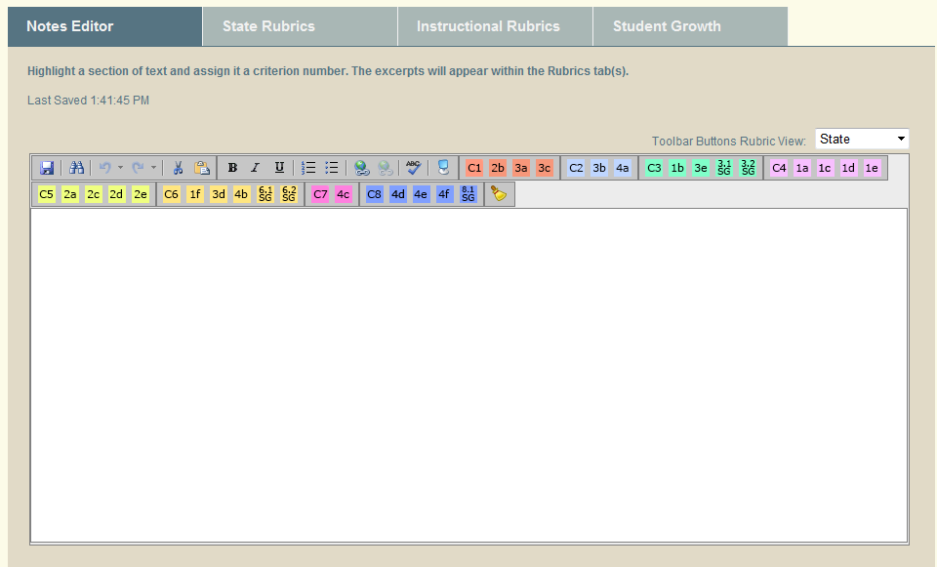

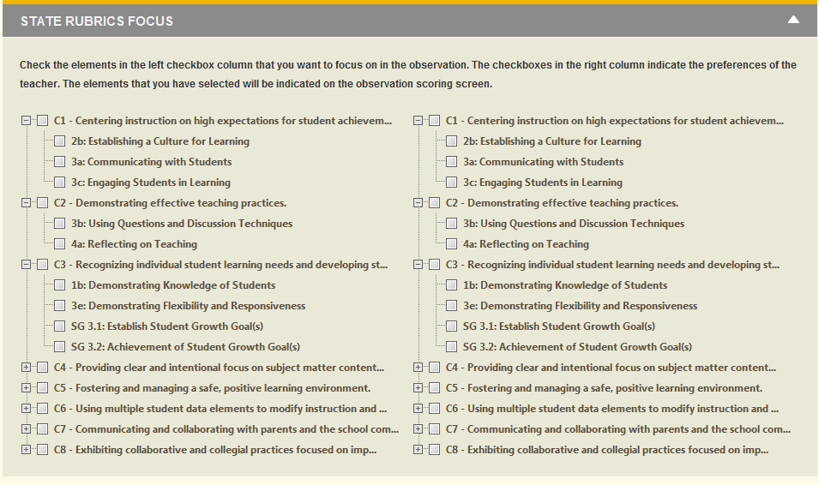

As you can see in the two screenshots above, there is a corresponding button on the Notes Editor toolbar for each of the nodes in the Pre-Conference Focus tree.